Stuart Jeffrey, Grant Visser

Team dynamic hunter

uml deSign document

# Logical Diagram

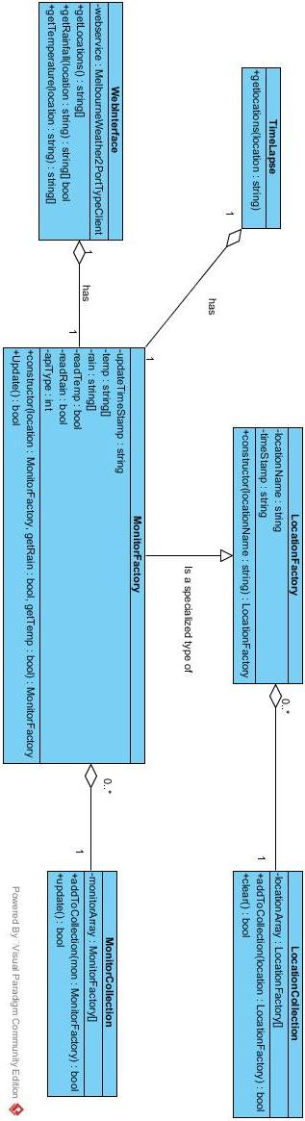

# Sequence Diagram

